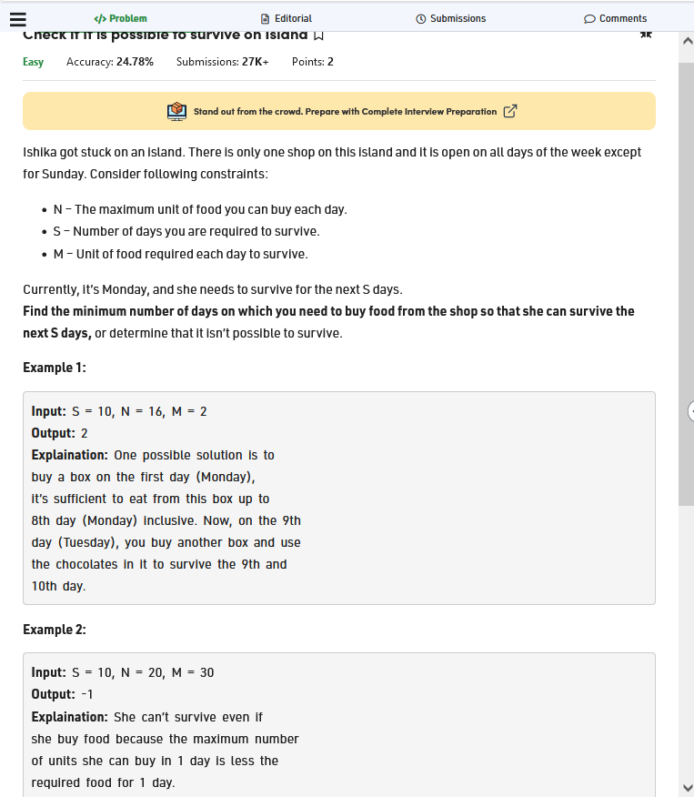

Code:

